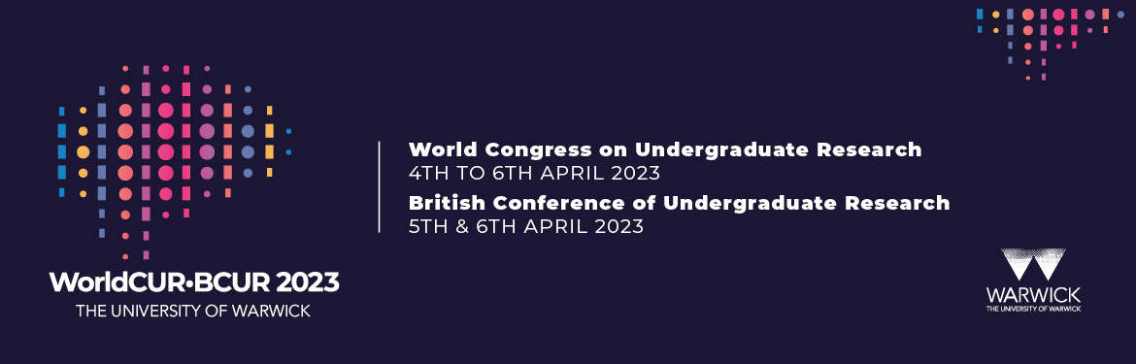

We are proud to announce that the University of Warwick will be jointly hosting the World Congress on Undergraduate Research (WorldCUR) & the British Conference of Undergraduate Research (BCUR) in April 2023.

This will be the first occasion when a national conference of undergraduate research has been brought together with the World Congress in a joint event. We are excited to provide this opportunity to share and network between communities, and that students from the UK and around the world will be able to showcase their research at a single event.

This will be the 3rd iteration of the World Congress on Undergraduate Research (WorldCUR) cementing its presence as a regular, prominent platform for showcasing global undergraduate research.

Also, the University of Warwick is honoured to be the first UK institution to host the annual British Conference of Undergraduate Research for a second time, having first hosted the event in 2012.
WorldCUR-BCUR will hold a joint keynote address and a joint conference dinner, in addition there will be opportunities for attendee at WorldCUR & BCUR to attend sessions at both conferences.

We welcome all undergraduate researchers, those who support undergraduate research, and all other interested attendees, to our self-contained campus (including accommodation, facilities, and entertainment) to join our celebration of undergraduate research!

We are actively seeking participation from the widest range of students and disciplines. We will be celebrating diversity in all forms: diversity of voice, diversity of ideas, and diversity of form of presentation. Please share these details with your students and colleagues and encourage them to join us for this exciting event.

We are delighted that WorldCUR-BCUR 2023 will be hosted by the University of Warwick as a full in-person conference experience. We will be utilising a range of resources to ensure the enjoyment and safety of our delegates, and we have the infrastructure to adapt our planning should the need arise.

The WorldCUR-BCUR call for abstracts is now OPEN!

Please let your current students (and recent graduates) know about this great opportunity to present their research and support them either to submit an abstract early, or to prepare a submission in the new academic year. We look forward to hearing from them.

If you are interested to find out more information, please visit our webpages www.warwick.ac.uk/worldcur-bcur2023 , including Frequently Asked Questions, and complete our expression of interest here.

Alternatively, email worldcur@warwick.ac.uk or bcur@warwick.ac.uk
Or follow us on social media
World CUR BCUR 2023
WorldCUR 2023
WorldCUR-BCUR 2023

#worldcurbcur2023 #WorldCUR2023 #BCUR2023 #WorldCUR #BCUR #UndergraduateResearch #UGResearch #undergraduateresearcher #undergraduateresearchconference

