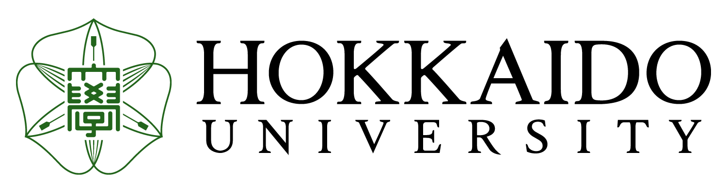

September, 2021

Dear Partner,

On behalf of Hokkaido University, I am pleased to inform you about one of our exchange programs called JLCSP (Japanese Language and Culture Studies Program) 2022 Spring Semester. We hope some of your students might be interested in joining JLCSP.

Enclosed please find the application form and application guidelines.

The outline of JLCSP Half-Year (2022 Spring Semester) is as follows:
1. Period: April 1, 2022 - August 31, 2022 (5 months)
2. Application Deadline: Friday, October 29, 2021 (Japan Standard Time)
3. Admission notification: Mid-December 2021
4. The objectives of this program are:
(1) to improve students' Japanese language proficiency in order to enable them to interact with Japanese speakers and to conduct research in Japanese.
(2) to acquire basic knowledge and methodology for Japanese studies - especially relating to Japanese general and applied linguistics.
(3) to gain a deeper understanding of Japanese language and culture through various courses.
5. Important Details:
- Qualification of applicants
Those who major Japanese language and culture in the undergraduate courses of the university–wide agreement partners of Hokkaido University. (Department-wide agreement partners not eligible) First-year students are not eligible to apply.
Those who have finished introductory level and reached intermediate level of Japanese language study at the time of submission: those who passed N3 or above level of the Japanese Language Proficiency Test or have equal ability with successful applicants of the test.
- How to submit application
Application materials need to be sent to Hokkaido University by email and posting.
- How we will manage the program
In light of the unceasing spread of COVID-19, we may be obliged to consider
providing our programs unordinary ways.

We hope you will recommend outstanding and highly motivated students to represent your university to study in the program.
If you have any questions, please contact us. (jlcsp@oia.hokudai.ac.jp).

Thank you for your cooperation in advance.

Sincerely Yours,



YAMAGUCHI Junji, Ph.D.
Executive Director, Institute for the Advancement of Higher Education
HOKKAIDO UNIVERSITY

