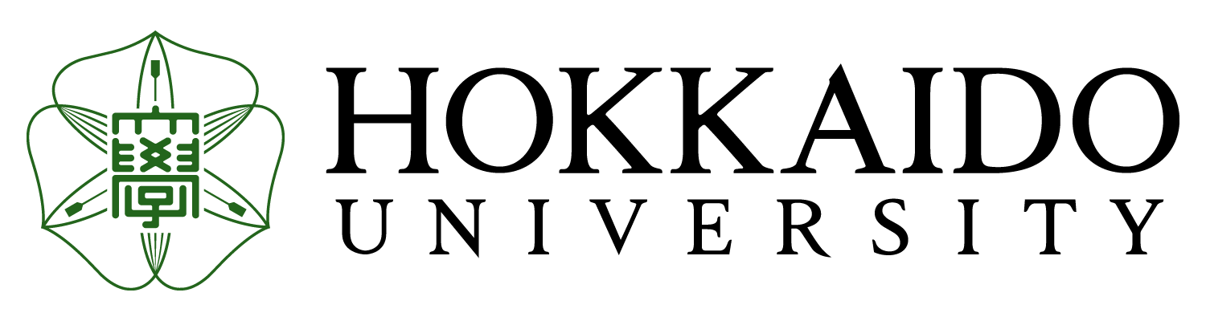

September,2021

Dear Partner,

On behalf of Hokkaido University, I am pleased to inform you about the application for our exchange programs, HUSTEP (Hokkaido University Short Term Exchange Program) 2022 Spring Semester Course, and application as special auditor (formerly stated as SAS) and special research student.

We hope some of your students might be interested in spending one semester or one year.
Please find attached the application form and application guidelines.

Please note that some condition and/or schedule is due to change depending on situations surrounding COVID-19 pandemic.

HUSTEP 2022 Spring Semester
Regarding the HUSTEP application forms and other required documents, you can download them from the HUSTEP website:
https://www.global.hokudai.ac.jp/admissions/exchange-student-admissions/exchange-programs-in-english-hustep/
The outline of HUSTEP 2022 Spring Semester Course is as follows:
1. Period of Enrollment: April 1, 2022– August 31, 2022 (5 months)
2. Application Deadline: October 29, 2021
3. Admission notification: mid-December, 2021
4. Program Features:
- Designed for undergraduate students both in Humanities and Science
- Courses in English (Japanese language ability is not required)
- Admission and tuition fee waiver
- Being eligible to apply for the Japan Student Service Organization (JASSO) scholarship if students
participate in HUSTEP
5. Important Details:
- Applications received after the deadline will not be accepted.
- Non-native English speakers must have a score of at least TOEFL iBT 79 or IELTS 6.5.
- Due to the capacity of the program, there is a screening process to select the participants. Not all
students who apply will be accepted.
- Only a very limited number of students can be nominated for the JASSO scholarship. In addition, applicants must be in Japan during exchange period to receive the scholarship.
6. The impact of COVID-19 outbreak on HUSTEP Spring 2022
The ongoing COVID-19 pandemic situation is still unpredictable in Japan. The Japanese government has currently suspended entry of international students, so no HUSTEP students are allowed to enter Japan at present as the entry ban still remains in place. In addition, we have no information as to when the border will reopen. Although we will hold HUSTEP Spring 2022 as scheduled, online options for courses will be provided to HUSTEP students unable to enter Japan due to border restrictions. Thus, please participate in the program by taking courses online until the border reopens.

* If you have any questions, please contact Ms. NONAKA, Maki, an administrative coordinator of HUSTEP program at hustep@oia.hokudai.ac.jp.

Exchange as Special Auditors or Special Research Students 2022 Spring

1. Period of Enrollment:
(1 semester) April 1, 2022 – September 30, 2022
(1 year) April 1, 2022 – March 31, 2023
2. Course Language: Special Auditor: JLPT N2 or Better, Special Research Student: Fluent in English or
Japanese.
3. Nomination Deadline: October 12, 2021
4. Application Deadline: November 12, 2021

*Notes: Please send us the nomination list using the nomination form attached. Application forms will be provided based on the nomination.

* If you have any questions, please contact Ms. KOBAYASHI Toko, an administrative coordinator of Exchange as Special Auditor or Special Research Student at exchange-programs@oia.hokudai.ac.jp.

We hope you will recommend outstanding and highly motivated students to represent your university to study in the program.

Thank you for your cooperation in advance.

Sincerely Yours,


YAMAGUCHI Junji, Ph.D.
Director of the Institute for
the Advancement of Higher Education
HOKKAIDO UNIVERSITY
Kita 15, Nishi 8, Kita-ku
Sapporo, Hokkaido 060-0815 JAPAN

