Title of Abstract (Center Aligned)

Background, Motivation and Objective
Explain what has been done previously and why this work is of importance. Point out the specific aim(s) of the presented work.

Statement of Contribution/Methods
Describe the new theory and/or technique, if applicable. State the experimental methods and equipment used.

Results/Discussion
Present the results obtained. Highlight important trends. State the scientific implication(s) of the presented findings.


- (b)
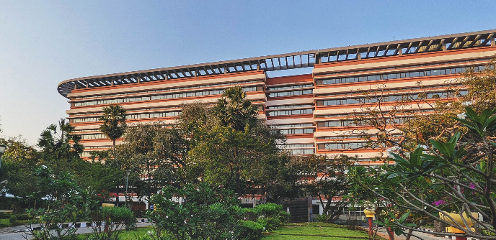

Submission Requirements
- The abstract should include a figure and/or table of results. It should not exceed 1 page with the figure/table included. The font should be Arial 11 point, and the margins should not be less than 0.75 inch/ 1.91 cm. Submissions that do not follow the guidelines may be penalized during peer-review.
- The figure, may contain subfigures and labels, but it should not have captions (i.e., do not include text such as “Fig. 1. Representative results”). Refer to the image within the main abstract text. The image must be scaled such that the entire abstract only spans one page.
- Please do not include author names, affiliations, and email addresses in the abstract. All abstracts will be subjected to double-blind review. Abstracts that contain author information may be rejected.
- Please avoid using terminology that might reveal the authors’ identity. For example, avoid self-citation phrases such as “we have previously shown (reference)…”.
- Please do not include sponsored research funding information in the abstract.
- If your submission includes an ethical statement, please do not include specific review board/ ethics committee names. Instead, use more generic phrases such as ‘The protocol was approved by an institutional review board/ institutional ethics committee’.

