**ICOE2025 Template— Title** Times New Roman, **Bold-face**, 14-point and Center

*Author Name(s): Firstname Middlename Family name*  (*Italic*, 10-point font and center)

Department Affiliation, School or Company Affiliation. (10-point font and center)

City, State or Province, Country 10-point font and center (No postal code)

E-mail Address here.

**ABSTRACT** (HEADING in CAPITAL and in bold face font.)

The abstract should be written in English, with a maximum length of two A4 pages, using 11-point Times New Roman font. The word count must not exceed 500 words.

We recommend using single line spacing (1.0). Figures and tables that are too large to fit within one column may span both columns. Captions for figures should be placed centered below the figure, while table captions should be centered above the table. Ensure that figures and tables appear only after they have been first mentioned in the text. Use the abbreviation "Fig. 1" when referring to figures, even at the beginning of a sentence, with the number placed in parentheses. Align the numbers flush with the right margin of the column, level with the last line of the equation.

Graphics can be in full color; however, please use only solid fill colors that provide a good contrast both on screen and in black-and-white print, as demonstrated in Fig. 1.

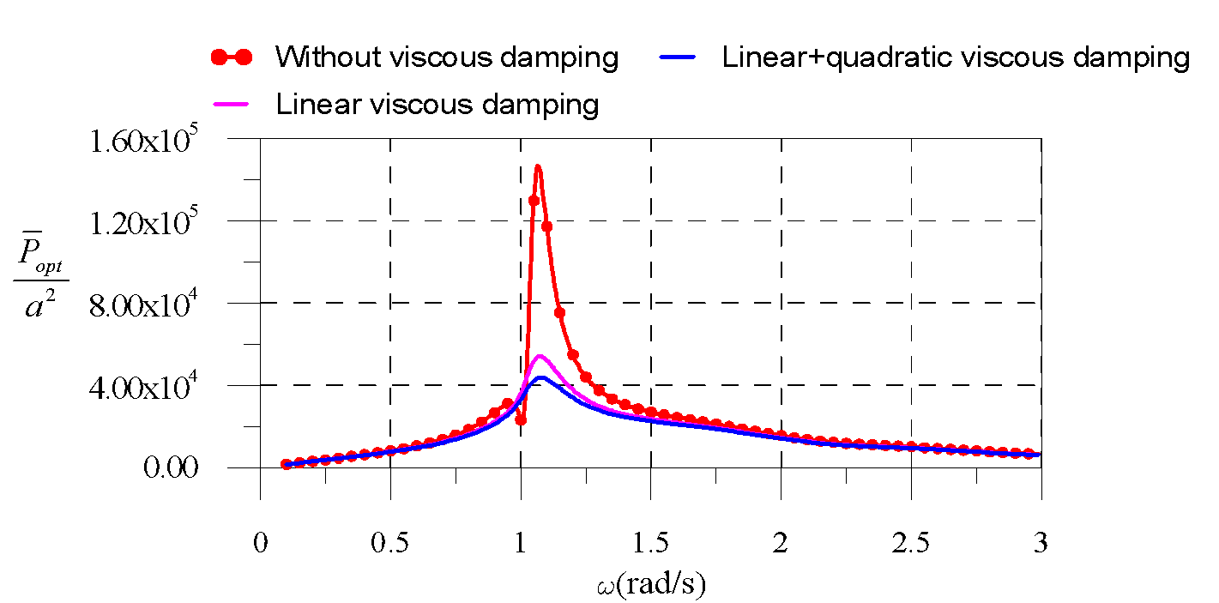

**Fig. 1. A sample line graph**

*(1 line spacing)*

**Keywords**: Four to six keywords separated by commas.