Title of the Contribution
A. Presenting-author¹, B. Co-author², C. Co-author¹
¹ Department, Institution, Address
² Department, Institution, Address

Please write your abstract in Times, 11pt, and indent (0.5cm) the first line of each paragraph. Use full (left/right) justification. Spacing below paragraphs is 6 pts and line spacing is 1.25 lines. Please do not exceed 1 page.
Please underline the presenting author in the author list, and save your file as an Adobe Acrobat pdf file with the family name of that author e.g. Arrhenius.pdf
All figures should be included in the text with caption outside the picture frame:
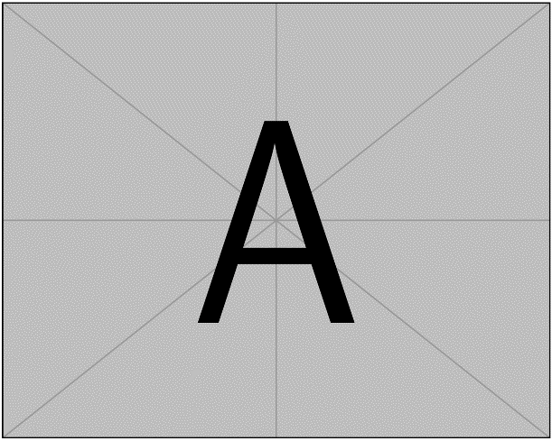
Figure 1: Caption

References
[1] A. Author, B. Author, etc., scientific journal, volume page (year).
[2] A. Author, B. Author, etc., scientific journal, volume page (year).

